FORGET ME NOT

System Design Specification

____________________________________________________________________________

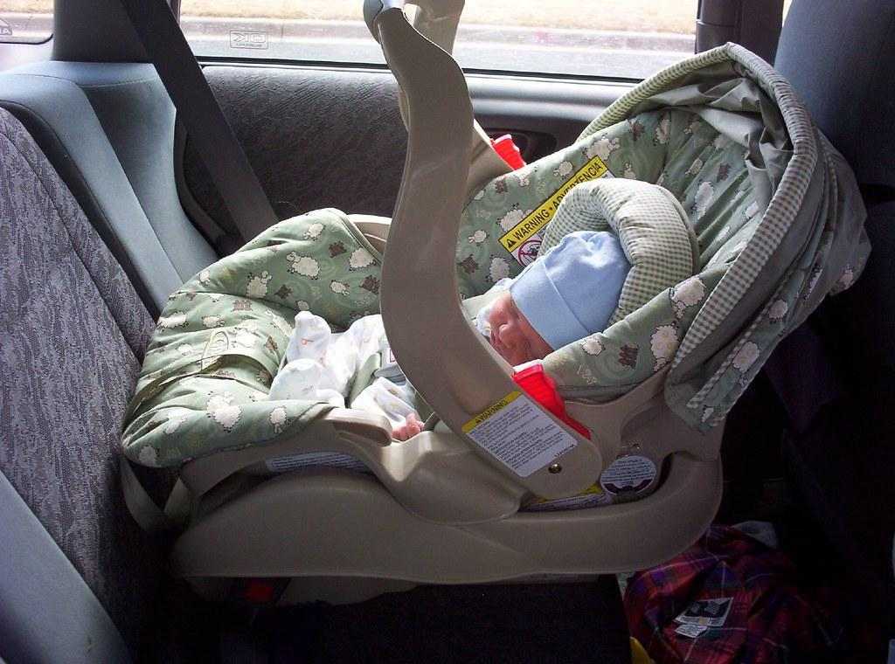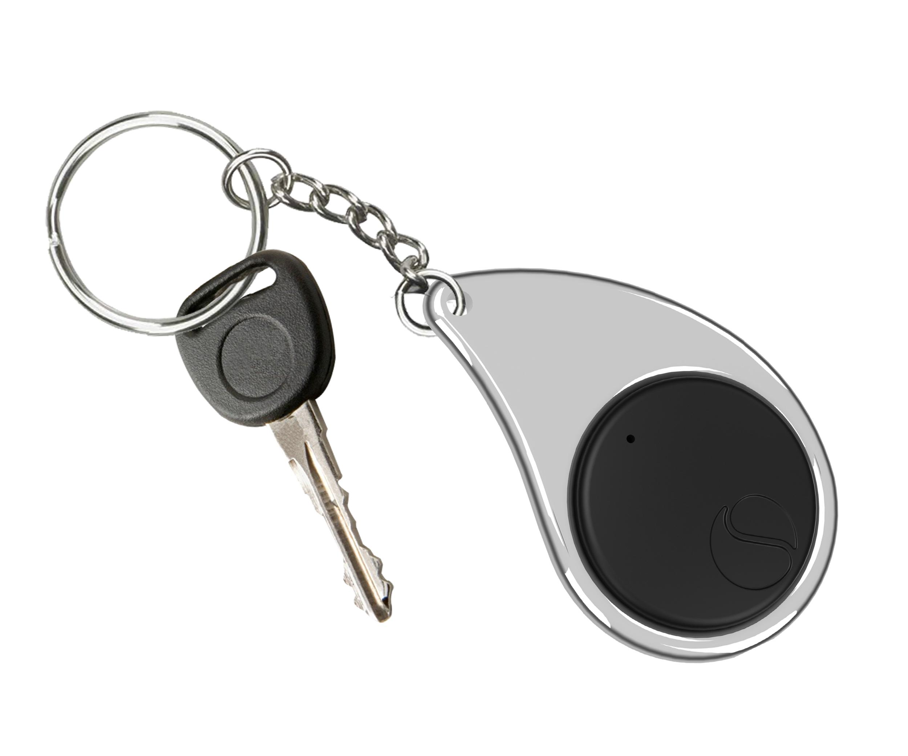

Revision 2

December 4, 2019

ECE 497 Capstone Project Group 1

Sponsor: Laura Ochsner

[lauraochsner@hotmail.com](mailto:lauraochsner@hotmail.com)

Group Members: Jacob Cassady

Mason Gardone

Raley Suter

Table of Contents

1. System Description 5

1.1. System Interfaces 5

1.1.1. External Interfaces 5

1.1.2. Internal Interfaces 6

1.2. System Requirements 7

1.2.1. The system must be able to survive heat of 175 degrees. 7

1.2.2. The system must retain working power for 8 ± 1 days on a single full charge. 7

1.2.3. Key Fob Subsystem shall be no larger than 1.5”x3”x1”. 7

1.2.4. Car Seat Subsystem shall be no larger than 5”x5”x1.5”. 7

1.2.5. The system shall be disarmed by pressing the disarm button on the Car Seat Subsystem. 7

1.2.6. Key Fob Subsystem shall make audible sound and vibrations once the fob exits a 20ft ± 5ft perimeter around the car module before the alarm is disarmed. 8

1.2.7. The system’s alarm sound should reach 80dB ± 5dB. 8

1.2.8. Alarm shall rearm automatically when user re-enters the perimeter of 20ft ± 5ft from the Car Seat Subsystem. 8

1.2.9. The system shall alert the operator via low power LED. 8

1.2.10. The Key Fob Subsystem must operate with reduced functionality at low power. 8

1.3. Major Components 8

1.3.1. Hardware Components 8

1.3.2. Software Components 12

2. Detailed Design 13

2.1. Hardware Components 13

2.1.1. MicroPython pyboard v1.1 Development Board 13

2.1.2. Adafruit Ultimate GPS Breakout Module 15

2.1.3. Digi Xbee3 Zigbee 3.0 RF Module 16

2.1.4. Power Sources 17

2.1.5. Power Estimation Circuit 17

2.1.6. PCB 18

2.1.7. 3D Printed Case 18

2.1.8. Sixfab Internal Active GPS Patch Antenna 19

2.1.9. W24P-U OEM Wi-Fi Antenna 19

2.1.10. Cylindrical Core SMT Vibration Motor 20

2.1.11. Piezoelectric Buzzer PKB24SPCH3601-B0 21

2.2. Software Components 22

2.2.1. Model 22

2.2.2. Communication Parser 24

2.2.3. Power Estimator 26

2.2.4. Distance Calculator 26

3. Principles of Operation 27

3.1. General Use 27

3.2. Team Developed Hardware Components 27

3.2.1. Power Estimation Circuit 27

3.2.2. Printed Circuit Board (PCB) 27

3.2.3. 3D Printed Case 28

3.3. COTS Hardware Components 28

3.3.1. MicroPython pyboard v1.1 Development Board 28

3.3.2. Adafruit Ultimate GPS Breakout Module 29

3.3.3. Digi Xbee3 Zigbee 3.0 RF Module 29

3.3.4. Power Source 29

3.3.5. W24P-U OEM Wi-Fi Antenna 29

3.3.6. Sixfab Internal Active GPS Patch Antenna 29

3.3.7. Cylindrical core SMT Vibration Motor 29

3.3.8. Piezoelectric Buzzer PKB24SPCH3601-B0 30

4. Test Procedures 30

4.1. Temperature Test 30

4.1.1. 1.2.1 - The system must be able to survive heat of 175 degrees. 30

4.2. Longevity Test 30

4.2.1. 1.2.1 - The system must retain working power for 8 ± 1 days on a single full charge. 30

4.3. Sizing Test 30

4.3.1. 1.2.3 - Key Fob Subsystem shall be no larger than 1.5”x3”x1”. 30

4.3.2. 1.2.4 - Car Seat Subsystem shall be no larger than 5”x5”x1.5”. 30

4.4. Alarm Disarm Test 30

4.4.1. 1.2.6 - The system shall be disarmed by pressing the disarm button on the Car Seat Subsystem. 31

4.4.2. 1.2.7 - Key Fob Subsystem shall make audible sound and vibrations once the fob exits a 20ft ± 5ft perimeter around the car module before the alarm is disarmed. 31

4.5. Sound Test 31

4.5.1. 1.2.8 - The system’s alarm sound should reach 80dB ± 5dB. 31

4.6. Rearm Test 31

4.6.1. 1.2.9 - Alarm shall rearm automatically when user re-enters the perimeter of 20ft ± 5ft from the Car Seat Subsystem. 31

4.7. Low Power Test 31

4.7.1. 1.2.10 - The system shall alert the operator via low power LED. 31

4.7.2. 1.2.11 - The Key Fob Subsystem must operate with reduced functionality at low power. 31

5. Requirements Traceability Matrix 31

6. Documents/Standards 32

6.1. GPS Standard 32

6.2. Telemetry Standard 33

7. Appendices 33

# System Description

The Forget Me Not Child Safety Device is made of two subsystems; one of which is placed in the car near the child and the other is held by the user. These two subsystems are defined as the car seat and key fob subsystems, respectively. As the two subsystems move away from each other, an alarm will sound unless the car seat system was previously disarmed. Both devices are controlled by a pyboard microcontroller. The subsystems communicate using radio frequency (RF) telemetry. The distance calculation is completed on the Key Fob subsystem using the global positioning system (GPS) modules. Each subsystem has two push buttons and different digital outputs. Refer to **Figure 1** for more information.

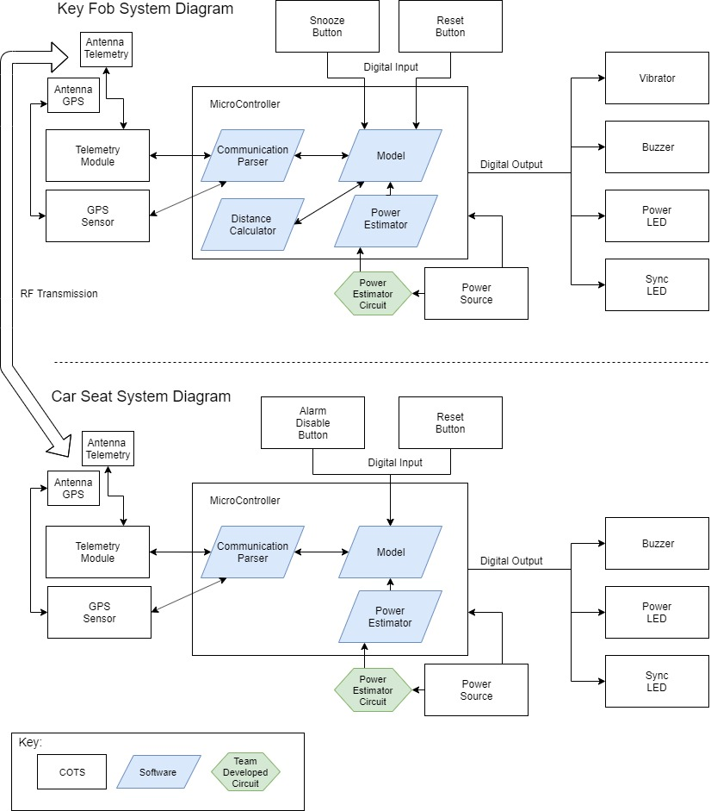

Figure 1 : System Diagram

## System Interfaces

### External Interfaces

#### Push Buttons

##### **Disarm Button**

The disarm push button is present only on the car seat subsystem. When pressed by the user, a digital signal will activate the Power light emitting diode (LED) to indicate the subsystem has power. When the disarm button is pressed and the two subsystems are in range and synchronized, a high digital signal to the microcontroller will disarm the audible and vibration alarms on the key fob subsystem.

##### **Reset Button**

The reset push button is on both subsystems. When this button is pressed, a digital signal is sent to the microcontroller. The subsystem will reset to the starting state in the program. This starting state is different for each subsystem.

##### **Snooze Button**

The snooze push button is present solely on the key fob subsystem. When pressed, the snooze push button will send a digital signal to the microcontroller to silence the alarm for 2 minutes ± 10 seconds.

#### GPS Communication

The GPS chip on each subsystem will be used to measure the location of each subsystem. The GPS chip will use an external antenna to broadcast radio waves.

#### Antennas

The antennas will be attached inside both subsystems’ chassis. The antennas will be receiving and transmitting information via radio waves. The GPS and RF telemetry chips will use different antennas.

#### LEDs

##### **Power LED**

This LED will be used to display information about power. Microcontroller sends a digital signal at a set duty cycle to make the LED blink or not blink.

##### **Reset LED**

The reset LED will flash when the system is reset. The LEDs that flash will be controlled by the microcontroller.

#### Power Source

The power source is a compact battery mounted inside the subsystems. Each subsystem will require a user to replace the batteries when power is low.

#### Vibration Motor

The vibrator will be mechanically attached to the 3D casing of the key fob subsystem. When the microcontroller activates the alarm function the vibration motor will turn and begin vibrating the subsystem.

### Internal Interfaces

#### Digital Outputs

Digital outputs are the data from the microcontroller to the LEDs, buzzer, vibration motor, GPS module, and RF telemetry module. The microcontroller will control the LEDs, the buzzer, and the vibration motor by sending a logic high to a switching device, allowing each of these end items to receive power. The GPS and RF integrated circuits (IC) will be sent data from the microcontroller using UART (Universal Asynchronous Receiver/Transmitter) and Rx/Tx connections.

#### Digital Inputs

The user will cause an input to the microcontroller to start a task via the on-board push buttons. The GPS and Telemetry ICs will send digital data via UART to the microcontroller.

#### Antenna to GPS and RF ICs

Signals received by the antenna will be directed to the GPS or RF telemetry modules. Each subsystem will have an antenna dedicated to the GPS module and an antenna dedicated to the RF telemetry module.

#### Power Source Connections

The power source will supply voltage to the microcontroller which supplies power to drive the other components. The power source feeds into the power estimation circuit through a high-side-driver-circuit which then feeds into an analog-to-digital converter (ADC) on the microcontroller.

## System Requirements

### The system shall survive temperatures up to 175 degrees Fahrenheit.

The Forget Me Not system is likely to endure high heat situations when kept inside a car. To account for this, the system must be tested to operate when exposed to temperatures 175 degrees Fahrenheit (80˚C) and below.

### The system shall retain working power for 8 ± 1 days on a single full charge.

The Forget Me Not system shall operate for several days of use. If the user is required to frequently change batteries on both subsystems, the benefit of the Forget Me Not system is greatly compromised. Both subsystems must remain operating after 8 ± 1 days of intermittent use.

### Key Fob Subsystem shall be no larger than 5.5”x3”x1.5”.

It is required that the key fob subsystem be designed such that it will fit on a keychain. The subsystem must be designed to be no larger than 5.5” in width, 3” in length, and 1.5” in thickness.

### Car Seat Subsystem shall be no larger than 5”x5”x2.5”.

It is required that the car seat subsystem be designed for storage in or under a car seat. The subsystem must be designed to be no larger than 5” in width, 5” in length, and 2.5” in thickness.

### The system shall be disarmed by pressing the disarm button.

The system shall enter the disarmed state when the disarm button is pressed. This button is located on the car seat subsystem. The disarm button shall disarm the system as long as a communication connection is available with the key fob subsystem.

### Key Fob Subsystem shall make audible sound and vibrations in triggered condition.

The key fob shall alarm the operator if they leave a 30m ± 10m perimeter around the car seat subsystem before disarming the system. This alarming will be performed with both sound and vibration.

### The system’s alarm sound shall reach 80dB ± 5dB.

The system must create an alarm sound that is both audible and non-damaging to the ears of any user. This value was chosen because 80dB ± 5dB is the threshold at which damage starts to occur to hearing.

### Alarm shall rearm automatically when user re-enters the perimeter of 30m ± 10m from the car seat subsystem.

The system shall enter the alarm state upon re-entry of the key fob into the alarm boundary. This is to ensure repeated working use of the system with no required user input outside of pairing the two subsystems and replacing batteries. This requirement can be validated by disarming the system, leaving the boundary, re-entering the boundary, and then leaving the boundary again. If this requirement is met, the alarm will sound.

### The system shall alert the operator of low power conditions using an LED indicator and an audible noise.

It is critical that the end-user be informed when the power for the system is almost depleted. This information is supplied to the user audibly and visually using a buzzer and an LED.

### The Key Fob subsystem shall operate with reduced functionality at low power.

In the case of the key fob subsystem reaching a low power condition, it must turn off all power consuming systems except supply to the low power indicators described above in section 1.2.9. This is to extend battery life to increase the likelihood of the user noticing the low power condition.

## Major Components

The Forget Me Not system contains the following hardware components: two Microcontrollers, two GPS breakout modules, two RF telemetry modules, two different power sources, two power estimator circuits, two printed circuit boards (PCB), two different 3D printed cases, four antennas, four push buttons, four LEDs, two buzzers, and one vibrator motor. Each microcontroller will also have four software components: a communicate parser, a model, a power estimator, and a distance calculator.

### Hardware Components

#### Microcontroller

The microcontroller used will be the Micro Python pyboard v1.1. All the digital inputs and outputs will connect to the motherboard via I/O pins, Rx/Tx, and UART connections. The power estimation circuit will also input into the pyboard through an ADC. The pyboard also will be attached to the PCB and mounted inside the 3D case. The link to the pyboard data sheet can be found in Appendix B.

##### Allocated Functional Requirements

1.2.1 - System must be able to survive heat of 175 degrees.

1.2.2 - System must retain power for 8 ± 1 days on a single charge.

1.2.5 - The system shall be disarmed by pressing the disarm button on the Car Seat Subsystem.

1.2.6 - Key Fob Subsystem shall make audible sound and vibrations when the fob is outside of 30m ± 10m from the car module before the alarm is disarmed.

1.2.8 - Alarm shall rearm automatically when user re-enters the perimeter of 30m ± 10m from the Car Seat Subsystem.

#### GPS Module

The Adafruit Ultimate GPS Breakout module will be used to determine the distance between the key fob and car seat subsystems. The GPS sensor will use an external Sixfab Active GPS Patch Antenna. The link to the GPS module data sheet can be found in Appendix B.

##### Allocated Functional Requirements

1.2.1 - System must be able to survive heat of 175 degrees.

1.2.2 - System must retain power for 8 ± 1 days on a single charge.

1.2.6 - Key Fob Subsystem shall make audible sound and vibrations when the fob is outside of 30m ± 10m from the car module before the alarm is disarmed.

1.2.8 - Alarm shall rearm automatically when user re-enters the perimeter of 30m ± 10m feet from the Car Seat Subsystem.

#### RF Telemetry Module

Each subsystem will have a Digi Xbee3 Zigbee 3.0 module responsible for facilitating communication between the subsystems. The telemetry module will communicate through radio waves via an antenna. The link to the Xbee data sheet can be found in Appendix B.

##### Allocated Functional Requirements

1.2.1 - System must be able to survive heat of 175 degrees.

1.2.2 - System must retain power for 8 ± 1 days on a single charge.

1.2.5 - The system shall be disarmed by pressing the disarm button on the Car Seat Subsystem.

1.2.6 - Key Fob Subsystem shall make audible sound and vibrations when the fob is outside of 30m ± 10m from the car module before the alarm is disarmed.

1.2.8 - Alarm shall rearm automatically when user re-enters the perimeter of 30m ± 10m from the Car Seat Subsystem.

#### Power Source

A compact battery will be used in the subsystems to provide required voltage and current. Each subsystem has its own power source mounted using a commercial off the shelf (COTS) battery holder. The links to the parts for the power supply can be found in Appendix B.

##### Allocated Functional Requirements

1.2.1 - System must be able to survive heat of 175 degrees.

1.2.2 - System must retain power for 8 ± 1 days on a single charge.

#### Power Estimator Circuit

The power estimator circuit is a high-side-driver circuit. A GPIO pin on the microcontroller will control the driver. With a voltage divider the battery voltage will be halved when connected to an ADC on the microcontroller. The links to the parts for the power estimation circuit can be found in Appendix B.

##### Allocated Functional Requirements

1.2.2 - System must retain power for 8 ± 1 days on a single charge.

1.2.9 - The system shall alert the operator via low power LED.

#### Printed Circuit Board (PCB)

Printed circuit board will be two layers. The PCB will have the power estimator circuit soldered to one side. The other major components will be attached to the PCB with surface mount and thru hole connections.

##### Allocated Functional Requirements

1.2.1 - System must be able to survive heat of 175 degrees.

1.2.3 - Key Fob Subsystem shall be no larger than 5.5”x3”x1.5”.

1.2.4 - Car Seat Subsystem shall be no larger than 5”x5”x2.5”.

#### 3D Printed Case

Each subsystem will have a 3D printed case in which all components will be housed. The key fob and car seat subsystems have different features; therefore, the physical 3D designs will differ.

##### Allocated Functional Requirements

1.2.1 - System must be able to survive heat of 175 degrees.

1.2.3 - Key Fob Subsystem shall be no larger than 5.5”x3”x1.5”.

1.2.4 - Car Seat Subsystem shall be no larger than 5”x5”x2.5”.

#### Antennas

The Internal Active GPS Patch Antenna will be used by the GPS module. The telemetry module will use the W24P-U for its antenna. Both antennas will be mounted inside the 3D case of the subsystems. The links to the antennas can be found in Appendix B.

##### Allocated Functional Requirements

1.2.6 - Key Fob Subsystem shall make audible sound and vibrations when the fob is outside of 30m ± 10m from the car module before the alarm is disarmed.

1.2.8 - Alarm shall rearm automatically when user re-enters the perimeter of 30m ± 10m from the Car Seat Subsystem.

#### Push Buttons

The subsystems will utilize the two push buttons present on the pyboard. The key fob subsystem will use one button for the snooze feature and the other button for resetting the subsystem. The car module will have one button for resetting and one button for disabling the alarm.

##### Allocated Functional Requirements

1.2.1 - System must be able to survive heat of 175 degrees.

1.2.2 - System must retain power for 8 ± 1 days on a single charge.

1.2.5 - The system shall be disarmed by pressing the disarm button on the Car Seat Subsystem.

#### LEDs

Two of the four LEDs on the pyboard are used for each subsystem. The LEDs are used as indicators to interface with the end user. One LED is used to indicate power status while the other is used to indicate a reset.

##### Allocated Functional Requirements

1.2.1 - System must be able to survive heat of 175 degrees.

1.2.2 - System must retain power for 8 ± 1 days on a single charge.

#### Buzzer

A Murata piezoelectric buzzer will be used to make the 80 ± 5 dB alarm that the system requires. The buzzer will be controlled by the microcontroller and mounted on the PCB. The buzzer data sheet can be found in Appendix B.

##### Allocated Functional Requirements

1.2.1 - System must be able to survive heat of 175 degrees.

1.2.2 - System must retain power for 8 ± 1 days on a single charge.

1.2.6 - Key Fob Subsystem shall make audible sound and vibrations when the fob is outside of 30m ± 10m from the car module before the alarm is disarmed.

1.2.7 - The System’s alarm sound should reach 80dB ± 5dB.

#### Vibrator Motor

The vibrator will be a coin vibrator motor mounted and glued to the 3D case of the key fob system. The vibrator motor will be activated when the microcontroller triggers the alarm. The link for the motor can be found in Appendix B.

##### Allocated Functional Requirements

1.2.1 - System must be able to survive heat of 175 degrees.

1.2.6 - Key Fob Subsystem shall make audible sound and vibrations when the fob is outside of 30m ± 10m from the car module before the alarm is disarmed.

### Software Components

#### Model

The model component is included in both subsystems. The model is a data structure with associated functions responsible for keeping track of the system’s dynamic state including the status of subsystems RF connection to the model. This component is important for the program to understand the moving parts. This component will be the central interface for all other software components.

##### Allocated Functional Requirements

* + - * 1.2.5 - The system shall be disarmed by pressing the disarm button on the Car Seat Subsystem.
      * 1.2.6 - Key Fob Subsystem shall make audible sound and vibrations when the fob is outside of 30m ± 10m from the car module before the alarm is disarmed.
      * 1.2.8 - Alarm shall rearm automatically when user re-enters the perimeter of 30m ± 10m from the Car Seat Subsystem.
      * 1.2.9 - System shall alert the operator of low power.
      * 1.2.10 - System must operate with reduced functionality at low power.

#### Communication Parser

The communication parser is included in both subsystems. The software module designed for communication parsing is important for packing data into a telemetry packet as well as unpacking data stored in a telemetry packet. The communication parser module will facilitate the encoding/decoding of data passed through the telemetry module. Also, the communication parser will be solely responsible for interfacing with the telemetry module.

##### Allocated Functional Requirements

1.2.5 - The system shall be disarmed by pressing the disarm button on the Car Seat Subsystem.

1.2.6 - Key Fob Subsystem shall make audible sound and vibrations when the fob is outside of 30m ± 10m from the car module before the alarm is disarmed.

1.2.7 - The System’s alarm sound should reach 80 ± 5 dB.

#### Power Estimator

The power estimator is included in both subsystems. The power estimator software module receives data from the power supply and uses it to estimate the amount of remaining power in the power supply.

##### Allocated Functional Requirements

1.2.2 - System must retain power for 8 ± 1 days on a single charge.

1.2.9 - System shall alert the operator of low power.

1.2.10 - System must operate with reduced functionality at low power.

#### Distance Calculator

The distance calculator is the only software component native to the Key Fob Subsystem without being included in the Car Seat Subsystem. This distance calculator takes two parameters, the GPS coordinates from each subsystem, and calculates the difference between them.

##### Allocated Functional Requirements

1.2.6 - Key Fob Subsystem shall make audible sound and vibrations when the fob is outside of 30m ± 10m from the car module before the alarm is disarmed.

1.2.8 - Alarm shall rearm automatically when user re-enters the perimeter of 30m ± 10m from the Car Seat Subsystem.

# Detailed Design

## Hardware Components

### MicroPython pyboard v1.1 Development Board

The MicroPython pyboard v1.1 Development Board comes equipped with a large selection of hardware. It contains a STM32F405RG microcontroller, a 168 MHz Cortex M4 CPU with hardware floating point, 1024KiB flash ROM and 192KiB RAM, a Micro USB connector for power and serial communication, a Micro SD card slot (supporting standard and high capacity SD cards), a 3-axis accelerometer (MMA7660), a real time clock with optional battery backup, 31 GPIO, three 12-bit analog to digital converters (ADC) available on 16 pins, 4 of which have analog ground shielding, two 12-bit digital to analog (DAC) converters available on pins 5 and 6, 4 LEDs, a reset and a user switch, an on-board 3.3V LDO voltage regulator capable of supplying up to 250mA with input voltage range 3.6V to 16V, and a DFU bootloader in ROM for easy upgrading of firmware.

Of this included hardware, the pyboard holds the following classes for easy control: ADC, SPI, IC, DAC, SD card storage, and UART. The pinout for the Development board can be found in **Figure 2**. Power and ground will be supplied to the pyboard through V+ and GND pins, power supplied by the batteries within each subsystem. Two GPIO pins will also be used to operate the sounder and the vibration motor components. The voltage level remaining in the system battery will be measured using the Power Estimation Circuit described in section 2.1.5 and the analog signal will be fed into the microcontroller through one of the three ADCs. Both switches and two of the four LEDs will also be used and are described in sections 2.1.1.1 and 2.1.1.2. One set of Rx and Tx data pins will be used to communicate with the GPS Breakout Module and one set of UART pins will be used to communicate with the RF telemetry module. Both modules will be powered from the pyboard 3V3 regulated output pins.

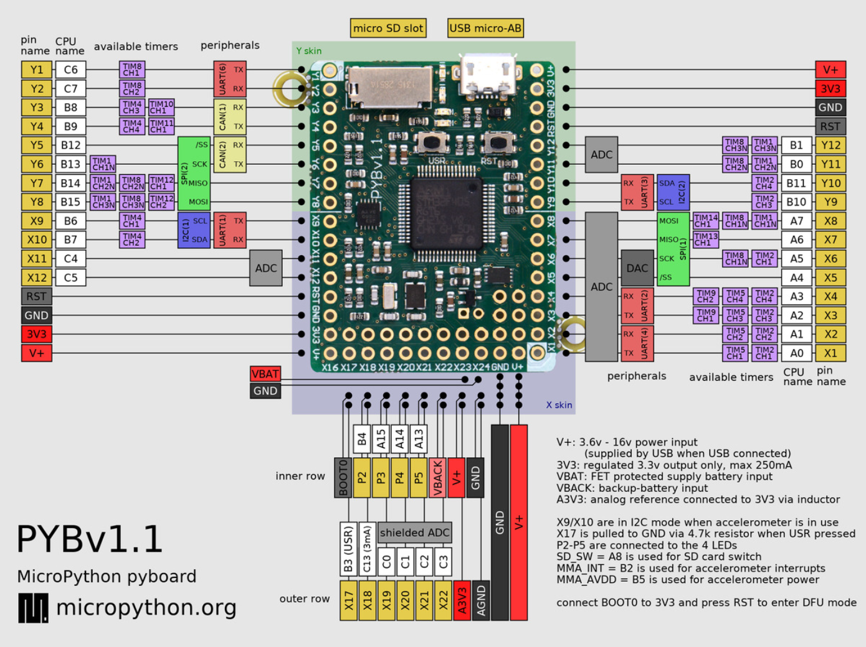

Figure 2 : MicroPython pyboard v1.1 Pinout

#### Push Buttons

The two pushbuttons, or switches, present on the pyboard are represented by their own class in MicroPython. This Switch class has three methods that allow the program to obtain the state of the switch or throw a flag when the state has been changed.

#### LEDs

There are four LEDs present on the pyboard. These LEDs work out of the box and can be controlled with a single function call. The fourth LED is blue and has an additional function associated with it to control its intensity. Only two of the LEDs will be used in either the Key Fob or Car Seat subsystem and these will merely be toggled on and off to indicate state.

### Adafruit Ultimate GPS Breakout Module

The Adafruit Ultimate GPS Breakout Module was designed to work easily with microcontrollers. It contains a built-in standard ceramic patch antenna that gives -165 dB sensitivity. For Projects in which the module may be enclosed in metal casing or not open to the sky, a uFL connection for an external antenna connection is also present. When a 3V external active GPS antenna is attached to this connection, the module automatically detects and switches to using the external antenna. The exterior antenna selected by the team is the Sixfab Internal Active GPS Patch Antenna, when attaching this antenna, a strain relief design must be used to prevent accidental removal of the fragile uFL connector. The Ultimate GPS Breakout Module requires 25mA of current when tracking and 20mA when navigating. As soon as the module is powered up and the Tx pin is connected, the microcontroller will receive data. The module immediately tries to find a fix in which the 2D (latitude and longitude) or 3D (latitude, longitude, and height) information is confirmed. This process can be a fast as 34 seconds under ideal circumstances but may take 30 minutes or longer in less ideal circumstances due to location, tall building, RF noise, and other factors. When a fix is obtained, this Adafruit module is position accurate to as little as 1.8 meters. There is also a small microcontroller with a small amount of flash memory present in the Ultimate GPS breakout module which can store up to 16 hours of data allowing the microcontroller to fall into low power mode and not be in constant communication with the GPS module. In this mode, the time, date, longitude, latitude, and height and logged every 15 seconds. The pinout for the GPS module is shown below in **Table 1**. Data is transmitted between the microcontroller and the GPS module via the TX and RX pins, and power and ground are supplied to the module via the VIN and GND pins, respectively.

Table 1 : Adafruit Ultimate GPS Breakout Pinout

|  |  |
| --- | --- |
| Pin | Purpose |
| 3.3V | Clean 3.3VDC, 100mA output. |
| EN | Enable pin. When pulled to ground, GPS module will turn off and in doing so will lose its fix. With no backup battery installed, finding the fix will take a long time. |
| VBAT | Input pin, connected to GPS real time clock battery backup. |
| FIX | When no fix, pulses up and down once per second. When there is a fix, the pin stays low (0V), pulses high for 200ms once every 15 seconds. |
| TX | Transmits data from GPS to microcontroller. 3.3V logic level, 9600 baud rate default. |
| RX | Transmits data to the GPS. 3.3V or 5V logic level, 9600 baud rate default. Requires checksummed NMEA sentences. |
| GND | Power and signal ground. Connect to microcontroller ground. |
| VIN | Power input, 3-5VDC |
| PPS | Pulses high (3.3V) once per second for 50-100ms. |

### Digi Xbee3 Zigbee 3.0 RF Module

The Digi Xbee3 Zigbee 3.0 RF Module comes in three styles, the selected style for the Forget Me Not device is the surface mount (SMT) style. The Digi Xbee3 modules are built support all protocols; the protocol being used by the team is the XBee 802.15.4. protocol. This module also is built to eliminate the need for an additional driving microcontroller and can create MicroPython smart end nodes. Technical specifications for the Digi Xbee3 can be seen below in **Table 2**. Characteristics related to system requirements in the below figure are range, transmit power, operating temperature, dimension, and supply voltage. The Xbee3 module will be mounted to the PCB using Samtec SMM-110-02-SM-S-TR header connectors. This will allow the Xbee3 to plug into the PCB rather than run the risk of damage during soldering. The pinout for the module is shown following in **Table 3**, pins vital for function are 1, 2, 3, and 10. These pins supply power and ground and provide the data path for sending and receiving from the other subsystem.

A separate module is required to configure the Xbee3 modules. The device used for this is a Xbee Xplorer USB which plugs directly into a PC and has headers to insert the Xbee3 modules into. Using a XCTU software provided for free from the manufacturer, the Xbee3 modules are given matching network PAN IDs to avoid crosstalk with other RF devices in the vicinity. Information on the download of this software can be found in Appendix E.

Table 2 : Digi Xbee 3 Technical Specifications

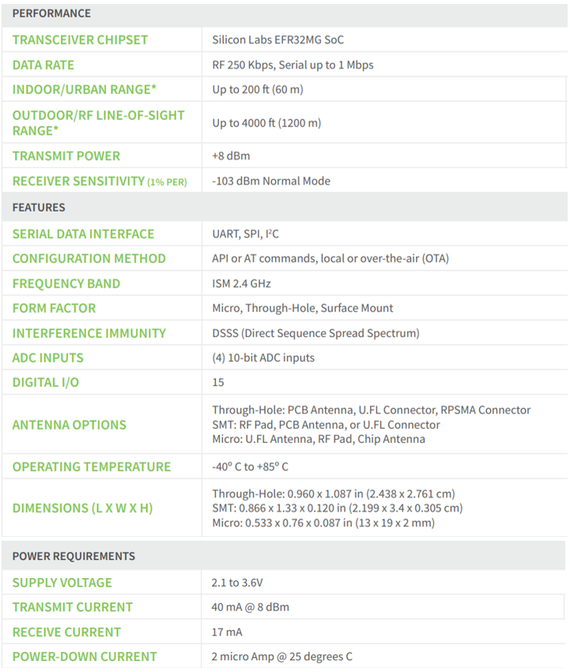

Table 3. Digi Xbee3 pinout.

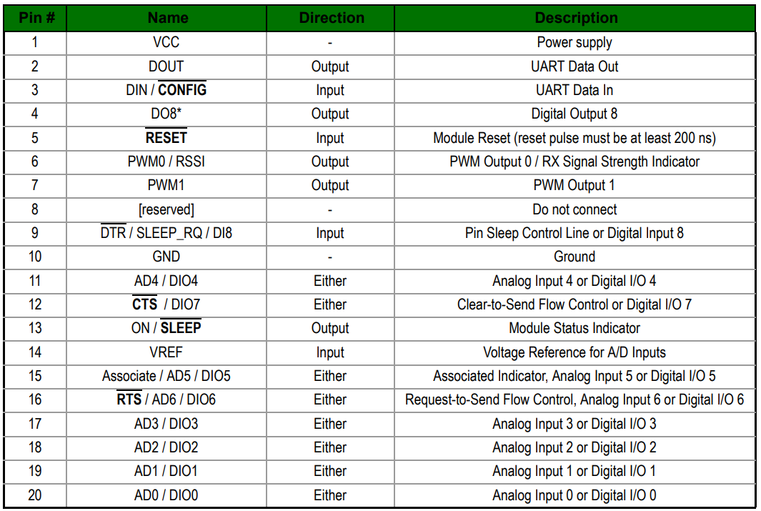

### Power Sources

The max load of the subsystems can reach 315mA. This number was found with the pyboard at full load and taking into count other components will not be driven constantly. Since the key fob subsystem has a size constraint of 5.5’’x 3’’ x 1.5’’ the batteries used had to be compact. The key fob subsystem has two CR2450 batteries connected in series to produce 6 volts and 620mAh to power the key fob for 2 hours at full load. The car seat subsystem is using 4 AA batteries in series to produce 6 volts and 2400mAh to power the system for 7.5 hours at full load. Both systems will have the batteries attached to the 3D case. The key fob will have two coin cell battery holders soldered directly to the PCB. The car seat subsystem will have a 4 cell battery holder with a cover.

### Power Estimation Circuit

To estimate the power of the system, the voltage of the battery will be measured via the ADC on the pyboard. The problem with the method is 300uA would be constantly drawn. So, a high-side driver circuit was implemented to stop the constant current draw. A GPIO pin on the pyboard will send a high signal to the NPN BJT. The BJT will pull the gate of the PMOS low allowing current to flow to the voltage divider circuit connected to the ADC of the pyboard. The voltage divider is set to halve Vin to 3V, which is safe for the VDC on the pyboard. The diode is added as fly back protection. The full circuit is shown in **Figure 3** and components are listed in **Table 4**. The circuit was simulated in Multisim and the results are shown in **Figure 4 and 5**. With this circuit when the GPIO pin is high there is a draw of 8.7mA. When the GPIO pin is low the current draw is 12.5nA which is 2400 times less than 300uA.

Table 4 : Power Estimation Circuit Components

|  |  |  |  |
| --- | --- | --- | --- |
| Part Number | Manufacturer | Description | Quantity |
| BSR17A | ON Semiconductor | Bipolar (BJT) Transistor NPN 40V 200mA 300MHz 350mW Surface Mount SOT-23-3 | 2 |
| BSH202,215 | Nexperia USA Inc. | P-Channel 30V 520mA (Ta) 417mW (Ta) Surface Mount TO-236AB | 2 |
| BAV19W-E3-08 | Vishay | Diode Standard 100V 250mA (DC) Surface Mount SOD-123 | 2 |
| MCT06030C1002FP500 | Vishay | 10 kOhms ±1% 0.125W, 1/8W Chip Resistor 0603 (1608 Metric) Anti-Sulfur Thin Film | 4 |
| MCT06030C1001FP500 | Vishay | 1 kOhms ±1% 0.125W, 1/8W Chip Resistor 0603 (1608 Metric) Anti-Sulfur Thin Film | 4 |

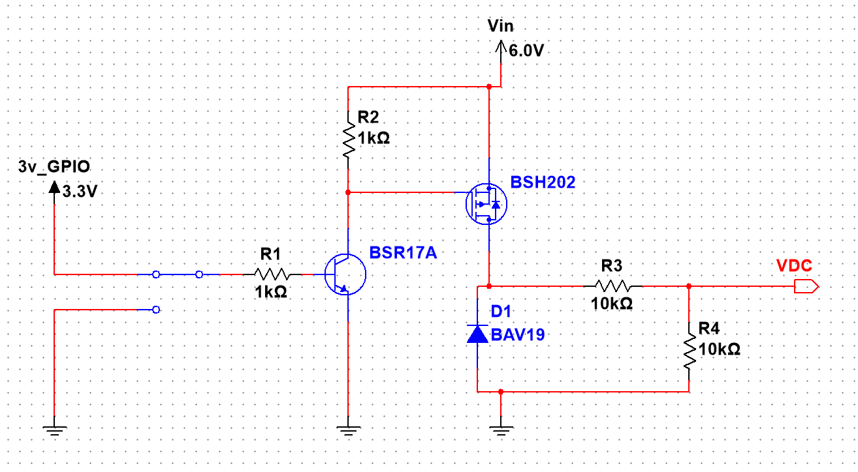

Figure 3 : Power Estimation Circuit Diagram

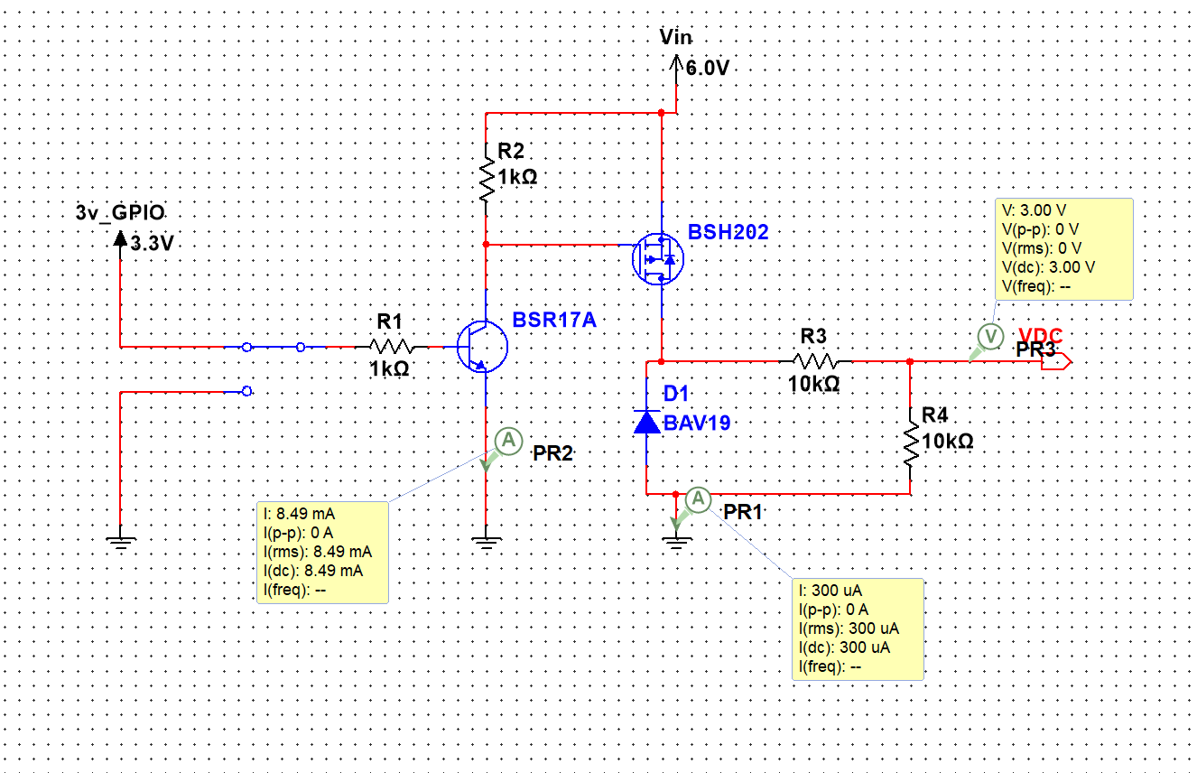

Figure 4 : Simulation with GPIO pin high.

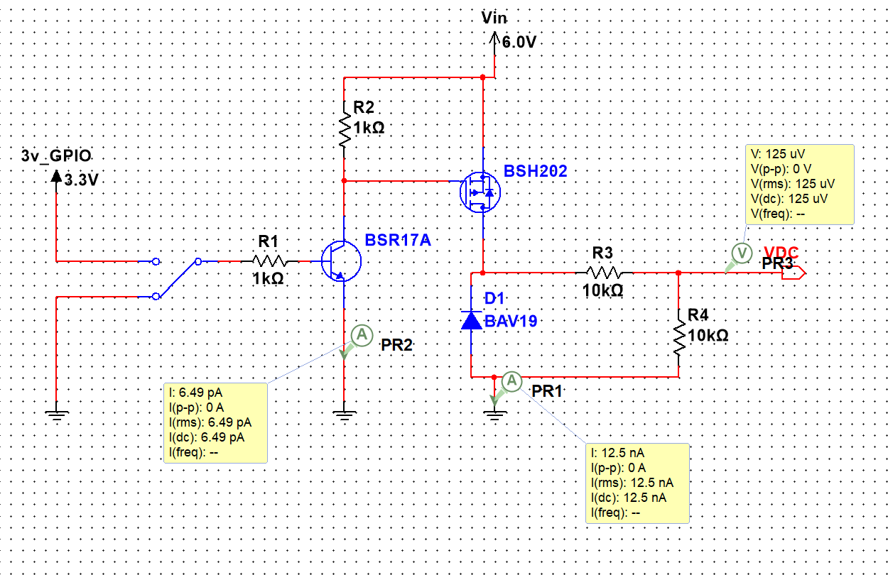

Figure 5 : Simulation with GPIO pin low.

### PCB

The PCB is a team developed device which hosts many of the other major components and provides the electrical connections and physical structure to the inside of each of the key fob and car seat subsystems. Major components soldered directly to the PCB include the Adafruit GPS module, the Digi Xbee3 telemetry module, CR2450 coin battery holders, the Z4FC1B1301781 vibration motor, the piezoelectric sounder, and the power estimation circuit. The layout for the PCB were designed using KiCad a free PCB cad software. Physical size a layout of parts in this design will be restricted by size constraints. The Car seat layout can be seen in **Figure 6** and the Key Fob layout in **Figure 7**.

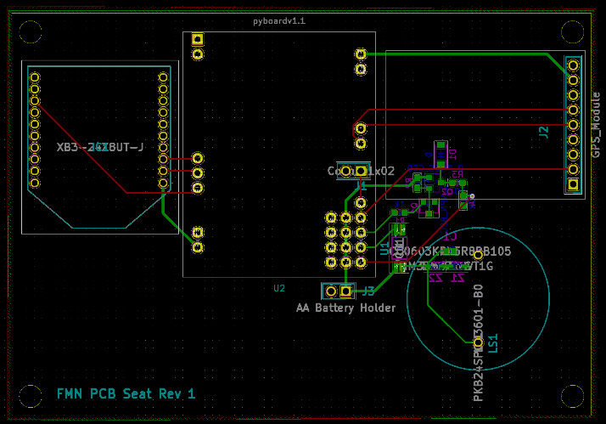

Figure 6: Car Seat subsystem PCB layout.

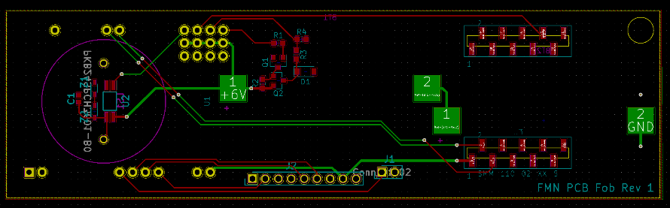

Figure 7: Key Fob subsystem PCB layout.

### 3D Printed Case

Size constraints and component lists vary slightly between the key fob and car seat subsystems. These differences will change the overall design of the casing, but critical pieces of the design - such as the mechanical design to connect the external push buttons with the pyboard push buttons and the location of the LED diffuser lenses – will not change. The cases will both be modeled in SolidWorks and then printed on a Monoprice IIIP Maker Select 3D Printer. The SolidWorks models will be imported into a software called Cura which can convert the files into a .gcode file extension which the 3D printers can handle. Information about download both of these programs is provided in section E of the Appendix.

#### Key Fob Casing

The key fob casing has critical dimensions of 5.5”x3”x1.5” inches. The design must incorporate exterior push buttons that will trigger the microcontroller pushbuttons. It must also have LED diffuser lenses set into place to allow the end user to see the state of the device based upon LED patterns. There must also be a battery hatch to allow easy replacement of the batteries as well as speaker holes to ensure the volume of the sounder is not dampened by the plastic casing. The dimension and design of the casing must be built around the interior layout of major components and how they are connected to the PCB.

An isometric view of the case design for the Keyfob module is shown in **Figure 8**. There is a top half and a bottom half to this design. When put together, they will sandwich the PCB and be held in place with a #6-32 machine screw. The printed pushbuttons used to press the buttons on the pyboard consist of two parts, a head and a shaft. These two pieces are glued together once inserted into a cutout exactly the same as that which can be seen on the right side of **Figure 9**. There are also shelves that are extruded up to hold the PCB level, a house for a square nut to allow the battery cover to be screwed in place, and a shelf for the vibration motor to insert into.

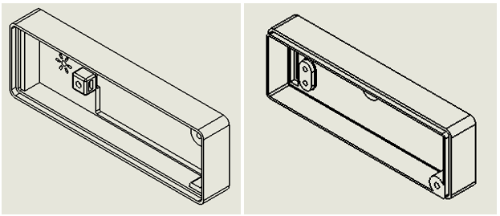

Figure 8: Key Fob casing.

#### Car Seat Casing

The car seat casing is not as critical in dimension as the key fob casing, with maximum dimensions of 5”x5”x2.5” inches. This casing must also contain two exterior push buttons, LED diffuser lenses, a battery hatch, and speaker holes. The batteries used in the car seat system, detailed in section 2.1.4, are different from those used in the key fob subsystem and therefore will require a different style of hatch. Many of the features present in this design are the identical to those in the keyfob case design. The differences include overall dimensions, the lack of a battery cover hole, and two screw holes which are used to hold the two halves of the case together. The 3D model for the carseat case is shown in **Figure 9**.

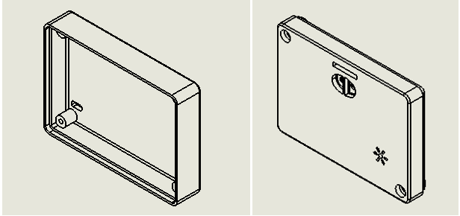

Figure 9: Carseat casing.

### Sixfab Internal Active GPS Patch Antenna

All the documented details provided by Sixfab about this antenna can be found below in **Table 5**. This antenna is designed to be easily implemented into any project. For the use in this project, it acts as a black box device with a single u.FL connection which plugs directly into the Adafruit ultimate GPS Breakout module described above. There are no configuration settings that require initialization or modification within this component. Signal and power are both provided through the single u.FL connector. This antenna also comes with an adhesive patch for easy mounting to an inside surface of the 3D printed cases described in section 2.1.5.

Table 5. Technical specifications for the Internal Active GPS Patch Antenna.

|  |  |
| --- | --- |
| Operating Current Draw | 5-12 mA |
| Operating voltage | 2.2-5 VDC |
| Dimensions | 25 X 25mm |
| Impedance | 50 Ω |
| Cable Length | 40mm |
| End Connection | u.FL |
| Polarization | RHCP |
| LNA Gain | 15+-2 dB |
| Noise Figure | 1.5 dB |
| Gain (Zenith) | 5 dBic |
| V.S.W.R. | < 2 |

### W24P-U OEM Wi-Fi Antenna

The W24P-U OEM Wi-Fi Antenna is the antenna used alongside the Digi Xbee3 Zigbee 3.0 RF Module for communication between the key fob and car seat subsystems. Technical specifications for this antenna can be found below in **Table 6**, and environmental operating conditions can be found below in **Table 7**. This antenna is a PCB antenna, selected for its compact size of 30 x 5 x 0.05mm. The W24P-U antenna has excellent sensitivity to consistently provide high signal reception efficiency. The antenna comes equipped with a 90mm cable and a u.FL connector on the end. This u.FL connector will plug directly into the Digi Xbee3. The range of frequencies supported by the W24P-U is 2400-2500 MHz so a frequency within this range must be selected for use in the Digi Xbee3.

Table 6. Technical specifications of the W24P-U Wi-Fi Antenna.

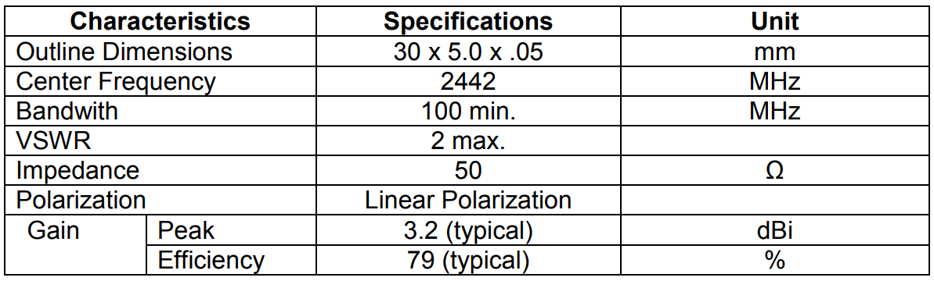

Table 7. Environmental Operation Ranges of the W24P-U Wi-Fi Antenna.

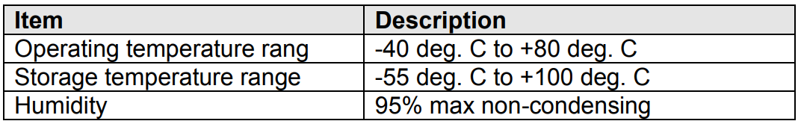

### Coin Vibration Motor

The major component vibration module is met using part C1020B111F from JINLONG MACHINERY & ELECTRONICS CO., LTD. This part is a coin vibration motor which rotates an unbalanced load at high rotational velocity, causing the entire component to vibrate. Standard operating conditions and electrical characteristic can be found below in **Tables 8 and 9**. This component has wire leads which will be soldered directly into the PCB, enabling the motor to receive power and still be mounted to the case of the subsystem. No external circuitry is required to operate this vibration motor other than a 3V power supply. This component will be soldered onto the team developed PCB, described in section 2.1.4, supplied with power from the selected battery described in section 2.1.3 controlled through the pyboard microcontroller described in section 2.1.1, and mounted to the 3D case described in section 2.1.7.

Table 8. Standard operating Conditions

|  |  |
| --- | --- |
| Item | Specification |
| Rated Voltage | 3V |
| Rated Load | Eccentric weight (~.50g) |
| Rotation Direction | Clockwise or counter clockwise |
| Motor Position | Any position |
| Voltage Range for use | 2.7-3.3 VDC |
| Operating Conditions | -20˚C-60˚C  65±20%RH |
| Storage Conditions | -30˚C-70˚C  65±20%RH |

Table 9. Electrical Characteristics.

|  |  |
| --- | --- |
| Item | Specification |
| Rated Current | 90mA max |
| Rated Speed | 9000 rpm |
| Stall Current | 120 mA max |
| Starting Voltage | 2.3 VDC max |
| Terminal Resistance | 31.0 OHM ± 15% OHM @25˚C |
| Insulation Resistance | 10 MOHM Min |

### Piezoelectric Buzzer PKB24SPCH3601-B0

The PKB24SPCH3601-B0 is a unified piezoelectric sounder. The device can operate independently with no external driving circuit or frequency required other than a 3-15 VDC power supply. The sounder has three terminals to mount thru-hole onto a PCB. The sound emission design is contained within a plastic case specifically designed for sound resonation with a small sound emission hole in the top. This sound resonation may be compromised if the casing is burned during soldering or if pins are pushed up into the casing when mounting. Technical specifications of the PKB24SPCH3601-B0 can be seen below in **Table 10**. In the current as-built version of this device, this component does not meet the operating temperature requirement. According to **Figure 10** below, the sound pressure specification is met at even the lowest operating voltage of this device. The dimensions of this device can be seen below in **Figure 11**, these dimensions are used in the design of the subsystem casing for both the key fob and car seat subcomponents. The sound duration during operation must at least equal 200 ms.

Table 10. Technical Specifications of the selected Piezoelectric Buzzer.

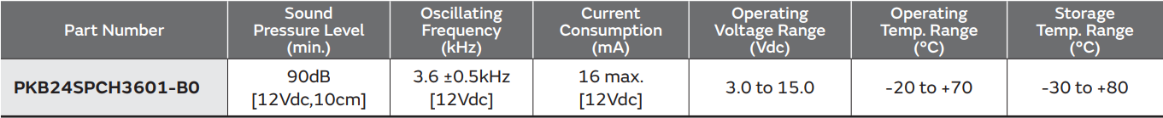

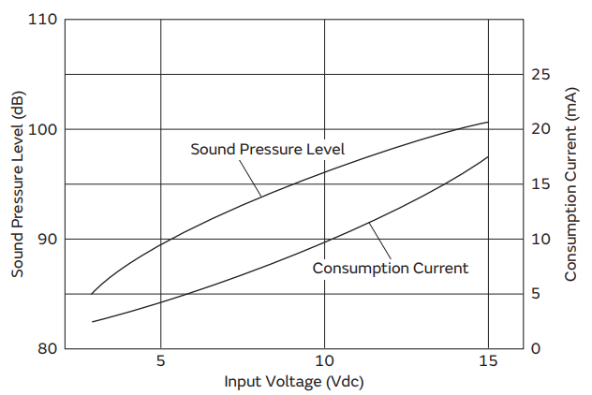

Figure 10. Input Voltage vs. Sound Pressure Level for the piezoelectric buzzer.

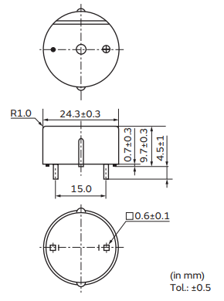

Figure 11. Physical Footprint of piezoelectric buzzer.

When implementing the buzzer onto the PCB, the following circuit diagrams are recommended for upstream current protection and volume control. **Figure 12** shows the recommended protection circuit to prevent inrush current damage with the presence of two Zener diodes. **Figure 13** shows the recommended circuit for volume control in which a 1 μF capacitor is placed in parallel with the device downstream from a resistor. Without the capacitor, the oscillation frequency will become unstable and affect sound quality.

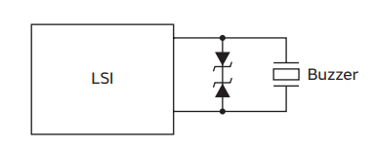

Figure 12. Overcurrent protection circuit.

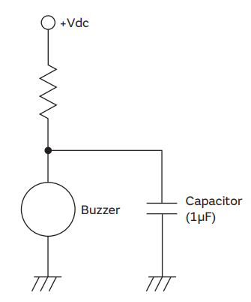

Figure 13. Volume control circuit.

## Software Components

All software components are designed as standalone threads to improve efficiency. The components with more intricate control flows have diagrams included in their sections. These diagrams all follow the same legend described in **Figure 14** below.

Figure 14 : Software Control Flow Legend

### GPS Module Update Thread

The GPS Module Update Thread runs at the maximum listed frequency from the GPS module’s hardware documentation, 10 Hz. It is constantly poling the uart pins to see if there is anything on Rx. If there is data, the thread tries to use it to update its MicroGPS class object. The MicroGPS class object is open source and designed for micropython. For more information, a link to the repository is in the references section of this document. Please see **Figure 15** for the control flow diagram of this thread.

Figure 15 : GPS Module Update Thread Control Flow Diagram

#### Allocated Functional Requirements

* 1.2.2 - System must retain power for 8 ± 1 days on a single charge.
* 1.2.6 - Key Fob Subsystem shall make audible sound and vibrations when the fob is outside of 30m ± 10m from the car module before the alarm is disarmed.
* 1.2.8 - Alarm shall rearm automatically when user re-enters the perimeter of 30m ± 10m from the Car Seat Subsystem.
* 1.2.10 - The Key Fob subsystem shall operate with reduced functionality at low power.

#### Derived Functional Requirements

##### The GPS Module Update Thread must have a low power state.

##### The GPS Module Update Thread must update at a maximum rate of 10 Hz to best capture the location of a moving key fob subsystem.

### Telemetry Module Listen Thread

The Telemetry Module Listen Thread runs at a maximum rate of 10 Hz. It is constantly poling the telemetry module’s UART Rx line to see if there are any new messages. When it receives one, it validates the string is complete by looking for starting and ending characters. It then updates the attributes and determines if it needs to update the armed state of the Key Fob Subsystem in response to a Car Seat Subsystem message. If no message is found, it waits for 100ms. Please see **Figure 16** for the control flow diagram of this thread.

Figure 16 : Telemetry Module Listen Thread Control Flow Diagram

#### Allocated Functional Requirements

* 1.2.2 - System must retain power for 8 ± 1 days on a single charge.
* 1.2.6 - Key Fob Subsystem shall make audible sound and vibrations when the fob is outside of 30m ± 10m from the car module before the alarm is disarmed.
* 1.2.8 - Alarm shall rearm automatically when user re-enters the perimeter of 30m ± 10m from the Car Seat Subsystem.
* 1.2.10 - The Key Fob subsystem shall operate with reduced functionality at low power.

#### Derived Functional Requirements

##### The Telemetry Module Listen Thread must have a low power state.

##### The Telemetry Module Listen Thread must operate at a frequency of 10 Hz or twice the frequency of the Telemetry Module Broadcast Position Thread.

##### The Telemetry Module Listen Thread must receive message from the Telemetry Module’s UART connection.

### Telemetry Module Broadcast Position Thread

The Telemetry Module Broadcast Position Thread runs at a maximum frequency of 5 Hz. It is constantly broadcasting the armed state of the subsystem, as well as the latitude and longitude attributes from the gps_module microGPS class object. It is important to note that these values default to zero when the gps module has not been able to parse a valid update from a GPS satellite. Please see **Figure 17** for the control flow diagram of this thread.

Figure 17 : Telemetry Module Broadcast Position Thread Control Flow Diagram

#### Allocated Functional Requirements

* 1.2.2 - System must retain power for 8 ± 1 days on a single charge.
* 1.2.5 - The system shall be disarmed by pressing the disarm button.
* 1.2.6 - Key Fob Subsystem shall make audible sound and vibrations when the fob is outside of 30m ± 10m from the car module before the alarm is disarmed.
* 1.2.8 - Alarm shall rearm automatically when user re-enters the perimeter of 30m ± 10m from the Car Seat Subsystem.

#### Derived Functional Requirements

##### The Telemetry Broadcast Position Thread must have a low power state.

##### The Telemetry Module Broadcast Position Thread must operate at a frequency of 5 Hz or half the maximum frequency of the GPS Module Update Thread.

##### The Telemetry Module Broadcast Position Thread must broadcast messages to the telemetry module’s UART connection.

##### The Telemetry Module Broadcast Position Thread shall rearm the alarm if the disarm button has not been pressed in 5 minutes.

### Car Seat Subsystem

The Car Seat Subsystem has a main thread as well as a GPS Module Update Thread and a Telemetry Module Broadcast Position Thread. The main thread starts these two threads and then monitors the systems power at a frequency of 0.2 Hz. If it determines, the response from the ADC is 75% of its starting value, the subsystem enters a low power state. 75% was used because the maximum value the ADC can read is 3.3V. 75% of 3.3V is around 2.4V. This is more than half our initial voltage of 6V. At this point, the subsystem will enter a low power mode and continue to monitor the power level in case the low value was erroneous. Please see **Figure 18** for the control flow diagram of this thread.

Figure 18 : Car Seat Subsystem Main Thread Control Flow Diagram

#### Allocated Functional Requirements

* 2.2.2 - System must retain power for 8 ± 1 days on a single charge.
* 2.2.9 - The system shall alert the operator via low power LED.

#### Derived Functional Requirements

##### The Car Seat Subsystem main thread must have a low power state.

##### The Car Seat Subsystem main thread must alert the user while in low power state.

### Key Fob Subsystem

The Key Fob Subsystem has a main thread as well as a GPS Module Update Thread and a Telemetry Module Listen Thread. The main thread starts these two threads and then monitors the systems power at a frequency of 0.2 Hz. If it determines, the response from the ADC is 75% of its starting value, the subsystem enters a low power state. 75% was used because the maximum value the ADC can read is 3.3V. 75% of 3.3V is around 2.4V. This is more than half our initial voltage of 6V. At this point, the subsystem will enter a low power mode and continue to monitor the power level in case the low value was erroneous.

Additionally, to monitoring the power the Key Fob Subsystem monitors for an alarm condition when not in low power mode. First it checks if it has received a message recently. If not and it was armed, it will sound the alarm. If it has received a message recently, it will check and see if it is armed. If it is not, it will check the state of the last message it received to update its armed states in accordance with the Car Seat Subsystem. If the system is armed at this stage, it will calculate the distance between the subsystems. If the subsystems are too far apart it will sound the alarm. If they are close enough together, it will quiet the alarm. Please see **Figure 19** for the control flow diagram of this thread.

Figure 19 : Key Fob Subsystem Main Thread Control Flow Diagram

#### Allocated Functional Requirements

* 2.2.2 - System must retain power for 8 ± 1 days on a single charge.
* 2.2.5 - The system shall be disarmed by pressing the disarm button.
* 2.2.6 - Key Fob Subsystem shall make audible sound and vibrations when the fob is outside of 30m ± 10m from the car module before the alarm is disarmed.
* 2.2.8 - Alarm shall rearm automatically when user re-enters the perimeter of 30m ± 10m from the Car Seat Subsystem.
* 2.2.9 - The system shall alert the operator via low power LED.
* 2.2.10 - The Key Fob subsystem shall operate with reduced functionality at low power.

#### Derived Functional Requirements

##### The Key Fob Subsystem main thread must have a low power state.

##### The Key Fob Subsystem main thread must alert the user while in low power state.

##### The Key Fob Subsystem main thread must alert the user if the subsystems are determined to be more than 30m apart when armed.

##### The Key Fob Subsystem main thread must alert the user if valid communication has not been received for more than 15 seconds when armed.

##### The Key Fob Subsystem shall disarm if it determines the Car Seat Subsystem is within 30 meters.

##### The Key Fob Subsystem shall snooze for 2 minutes if the disarm button is pressed.

### Distance Calculator

The Distance Calculator software module is used for calculating the distance between two GPS coordinates. Each GPS coordinate is represented as a pair of latitude and longitude floating point values. The distance between these two coordinates is then calculated using the Haversine Formula described in **Equation 1** below where represents the latitude of a coordinate and λ represents the longitude.

Equation 1 : Haversine Formula



# Principles of Operation

## General Use

The Forget Me Not System is set up by placing the Car Seat Subsystem under or attached to the car seat of a child and powered on. The Key Fob Subsystem should be placed on the operator's key fob and powered on. When the Key Fob Subsystem is within a perimeter of 30 meters +/- 10 meters, an alarm is armed on the Key Fob Subsystem. This alarm will sound and vibrate when the Key Fob Subsystem exits the perimeter without disarming.

To disarm the alarm, the operator must press the disarm button until the alarm stops. This disarms the alarm while within the perimeter of 30 meters +/- 10 meters from the Car Seat Subsystem indefinitely. To rearm the system after disarming, the operator must first exit the perimeter and then re-enter.

When the battery is low, the Key Fob Subsystem will operate with reduced functionality no longer communicating with the Car Seat Subsystem. When this occurs, the operator will see the low power LED blinking on the Key Fob Subsystem. The operator must replace the two coin cell batteries and restart the subsystem. If the Car Seat Subsystem is running low on battery, it will behave similarly. The operator must replace the 4 AA batteries and restart the subsystem for the entire system's alarm to arm properly.

## Team Developed Hardware Components

### Power Estimation Circuit

The power estimation circuit is to be built on one side of the PCB. This circuit takes advantage of the analog to digital converter (ADC) built on the Micropython pyboard v1.1 Development Board. The circuit, when active, will supply the ADC with the present voltage level being supplied by the voltage source. The power estimation circuit contains a voltage divider circuit in order to reduce the voltage level to meet the specifications of the ADC on the pyboard. This circuit also contains a high-side driver using a PMOS transistor and an NPN BJT by a pin on the pyboard, see **Figure 3**  in section 2.1.5. This reduces the constant power consumption of the ADC and allows a software function to be written which controls when the ADC will receive a signal.

### Printed Circuit Board (PCB)

The printed circuit board developed by the team houses the power estimation circuit described above and provides a base for the connections between other major components.

### 3D Printed Case

The Casing component is the only major component that requires mechanical design in this system. The Casing is 3D printed plastic that houses all the rest of the major components. The 3D printed casing for the key fob subsystem will be different than that for the car seat subsystem. As seen in **Figure 1**, the system diagram detailing the two subsystems, the two subsystems have slightly different requirements. The Casing operates to secure each major component in one location and houses the major exterior interfaces important to the end user. Light diffusing lenses will be set into the casing to allow the light from the pyboard built-in LEDs to be seen outside each subsystem. The casing also houses two buttons which mechanically press the pyboard built-in touch sensors. This allows each subsystem to operate as a “black box” system to the end user; each operator will only be required to interact with two labeled buttons, two LEDs which can be seen outside the casing, and a removable cover for battery replacement.

## COTS Hardware Components

### MicroPython pyboard v1.1 Development Board

The Micropython pyboard contains many hardware components unused by this system. The hardware components used include an ADC, GPIO pins, UART pins, on-board switches, and on-board LEDs. The ADC is used to estimate the remaining battery life alongside the power estimation circuit. The GPIO pins are used to control the on/off state of end components such as the vibration motor and the piezoelectric sounder. The UART pins are used to receive and transmit data to and from the GPS Breakout module and the RF telemetry module. The on-board switches and LEDs have built-in libraries to control and read state changes. Additional information regarding the MicroPython pyboard v1.1 Development Board can be found in the appendix.

### Adafruit Ultimate GPS Breakout Module

The Adafruit Ultimate GPS Breakout Module has very low power consumption which is an important feature for this project. The module also requires 3.3V which is compatible with the MircoPython pyboard v1.1. More information about the GPS Breakout module can be found in the appendix.

### Digi Xbee3 Zigbee 3.0 RF Module

The Xbee3 Zigbee is compact and has the features needed for wireless communication. The RF module uses the IEEE 802.15.4 networking protocol attach in the standards section. More information about the operation of the Digi Xbee3 Zigbee 3.0 RF Module can be found in the appendix.

### Power Source

The key fob subsystem will be powered with two CR2450 batteries connected in series to supply 6V at 620mAh. Two signal cell CR2450 battery holders will be soldered to the PCB to hold the batteries. The car seat subsystem will have four AA batteries in series to supply 6V a 2400mAh. The car seat subsystem will use an AA battery holder. More information about the batteries can be found in the appendix.

### W24P-U OEM Wi-Fi Antenna

The W24P-U OEM Wi-Fi antenna will work with 24000-2500 MHz signals. The antenna will plug directly into the U.FL port on the Xbee3 3.0 RF module as its antenna. More information about the W24P-U OEM Wi-Fi antenna can be found in its datasheet attached in the appendix.

### Sixfab Internal Active GPS Patch Antenna

This GPS Patch Antenna operates with a simple plug and play system. There is a u.FL connector which plugs directly into the Adafruit Ultimate GPS Breakout module. No additional circuitry or power is required to operate the antenna. This component also comes equipped with an adhesive pad for easy mounting within the subsystem casing. More information about the GPS patch antenna can be found in its datasheet attached in the appendix.

### Coin Vibration Motor

The Coin Vibration Motor is a DC driven device that vibrates when powered. The motor has an attached unbalanced load which is rotated at high frequency. The unbalance load shakes the motor and ultimately causes the entire key fob subsystem to vibrate. More information about the vibration motor can be found in its datasheet attached in the appendix.

### Piezoelectric Buzzer PKB24SPCH3601-B0

The piezoelectric buzzer has a max decibel value of 90 dB and is rated for voltages ranging from 3 to 15 volts. The PKB24SPCH3601-B0 is also internally driven so no driver circuit is needed. More information about the Piezoelectric Buzzer can be found in its datasheet attached in the appendix.

# Test Procedures

## Temperature Test

The Temperature Test requires the system's communication to be tested while one of the subsystems is held in an environment with a temperature of 175 degrees. The system must be able to create an alarm event under these circumstances and successfully rearm itself after the user re-enter the perimeter.

### 1.2.1 - The system must be able to survive heat of 175 degrees.

## Longevity Test

The Longevity Test requires the system to operate properly for 8 ± 1 days with at least 2 alarm and rearm events occurring each day of operation. This ensures long duration working operation of the system.

### 1.2.1 - The system must retain working power for 8 ± 1 days on a single full charge.

## Sizing Test

The Sizing Test requires the system to be measured to assure each subsystem is within its dimensional requirements. The Key Fob Subsystem must measure to have a width less than 5.5”, a height of less than 3”, and a thickness of less than 1.5”. The Car Seat Subsystem must measure to have a width less than 5”, a height of less than 5”, and a thickness of less than 2.5”.

### 1.2.3 - Key Fob Subsystem shall be no larger than 5.5”x3”x2.5”.

### 1.2.4 - Car Seat Subsystem shall be no larger than 5”x5”x2.5”.

## Alarm Disarm Test

The Alarm Disarm Test validates the alarm is shut off when the disarm button is pressed. The operator must create a circumstance where an alarm event occurs by walking outside of a perimeter for 30 meters ± 10 meters from the car seat subsystem with the key fob subsystem while the alarm is armed.

### 1.2.6 - The system shall be disarmed by pressing the disarm button on the Car Seat Subsystem.

### 1.2.7 - Key Fob Subsystem shall make audible sound and vibrations once the fob exits a 30m ± 10m perimeter around the car module before the alarm is disarmed.

## Sound Test

The Sound Test ensures the alarm reaches an intensity level of 80dB ± 5dB. The intensity level must be measured from a distance of 1 meter from the system to account for the distance between the operator’s pocket and their ear. The intensity level will be checked using a smartphone decibel meter app.

### 1.2.8 - The system’s alarm sound should reach 80dB ± 5dB.

## Rearm Test

The Rearm Test requires the operator to disarm an armed alarm while in the perimeter, walk outside of the perimeter of 30m ± 10m without an alarm event occurring, re-enter the perimeter, and then leave the perimeter with an alarm event occurring. This ensure that the subsystem properly rearmed itself after reentering the perimeter area.

### 1.2.9 - Alarm shall rearm automatically when user re-enters the perimeter of 30m ± 10m from the Car Seat Subsystem.

## Low Power Test

The Low Power Test requires the user to use a direct current power supply to lower the input voltage from 6 volts to below 3.3 volts. Once at low power the subsystem must begin blinking its low power LED to warn the user. Additionally, the subsystem must stop utilizing its telemetry and GPS modules to ensure the warning LED stays on as long as possible. This can be tested by ensuring the broadcast from the subsystem stops once the LED begins to blink.

### 1.2.10 - The system shall alert the operator via low power LED.

### 1.2.11 - The Key Fob Subsystem must operate with reduced functionality at low power.

# Requirements Traceability Matrix

Table 14 : Requirements Traceability Matrix

|  |  |  |  |
| --- | --- | --- | --- |
| **Requirement** | **Requirement Description** | **Test** | **Pass/Fail** |
| 1.2.1 | The system must be able to survive heat of 175 degrees. | 4.1 | TBD |
| 1.2.2 | The system must retain working power for 8 ± 1 days on a single full charge. | 4.2 | TBD |
| 1.2.3 | Key Fob Subsystem shall be no larger than 5.5”x3”x1.5”. | 4.3 | Pass |
| 1.2.4 | Car Seat Subsystem shall be no larger than 5”x5”x2.5”. | 4.3 | Pass |
| 1.2.5 | The system shall be disarmed by pressing the disarm button on the Car Seat Subsystem. | 4.4 | Pass |
| 1.2.6 | Key Fob Subsystem shall make audible sound and vibrations once the fob exits a 30m ± 10m perimeter around the car module before the alarm is disarmed. | 4.4 | Pass |
| 1.2.7 | The system’s alarm sound should reach 80dB ± 5dB. | 4.5 | TBD |
| 1.2.8 | Alarm shall rearm automatically when user re-enters the perimeter of 30m ± 10m from the Car Seat Subsystem. | 4.6 | Pass |
| 1.2.9 | The system shall alert the operator via low power LED. | 4.7 | Pass |
| 1.2.10 | The Key Fob Subsystem must operate with reduced functionality at low power. | 4.7 | Pass |

Table 15 : Validation Table

|  |  |  |
| --- | --- | --- |
| **Test Number** | **Tests** | **Requirement Fulfilled** |
|  |  |  |
|  |  |  |
|  |  |  |
|  |  |  |

# Documents/Standards

## GPS Standard

United States, A. F. (2017, 8 22). *GPS Performance Standards and Specifications*. Retrieved 9 17, 2019, from Official U.S. government information about the Global Positioning System (GPS) and related topics: <https://www.gps.gov/technical/ps/>

## Telemetry Standard

IEEE 802.15.4 - <http://www.ieee802.org/15/pub/TG4.html>

# Appendices

Shared appendices with the final report document.